Multiple-choice section

|  |  |  |  |  |  |  |
| --- | --- | --- | --- | --- | --- | --- |
| Question | 1 | 2 | 3 | 4 | 5 | 6 |
| Answer | B | D | A | D | C | A |

Question 1 [8.3]

B

P(x) = x3 – x2 – 4

P(-2) = (-2)3 – (-2)2 – 4  
= -8 – 4 – 4   
= -16

Question 2 [8.2]

D

To transform y = x2 to y = -x2, reflect in the x-axis.  
To transform y = -x2 to y = -3x2, dilate by a factor of 3 in the y direction.  
To transform y = -3x2 to y = 6 – 3x2, translate 6 units up.

Question 3 [8.3]

A

P(x) = x2 – 2x4 + 7

= -2x4 + x2 + 7

Degree = 4 Leading coefficient = -2 Constant = 7

Question 4 [8.3]

D

P(x) = x3 – x2 + 3x + 2

P(1) = 13 – 12 + 3 × 1 + 2

= 1 – 1 + 3 + 2

= 5

Question 5 [8.5]

C

y = 2x3 + 5x2 – x + 6

For x = 0: y = 6

Question 6 [8.2]

A

y = x3

Dilating by a factor of 5: y = 5x3  
Translating the graph 2 units to the right: y = 5(x – 2)3  
Translating the graph 1 unit down: y = 5(x – 2)3 – 1

Multiple-choice total marks: 6

Short answer section

Question 7 3 marks [8.1, 8.3]

(a) The degree of a polynomial is the value of the highest power in the polynomial.

(b) The equation y = 3x2 – 4x + 1 is a non-monic quadratic equation.

(c) In a polynomial, the term with the highest power is called the leading term.

Question 8 1 mark [8.2]

A dilation occurs when a polynomial is stretched in one direction. If the polynomial is dilated away from the x-axis, the polynomial is stretched in the direction of the y-axis. A dilation changes the shape of the graph making it narrower or wider.

Question 9 4 marks [8.2]

(a), (c)

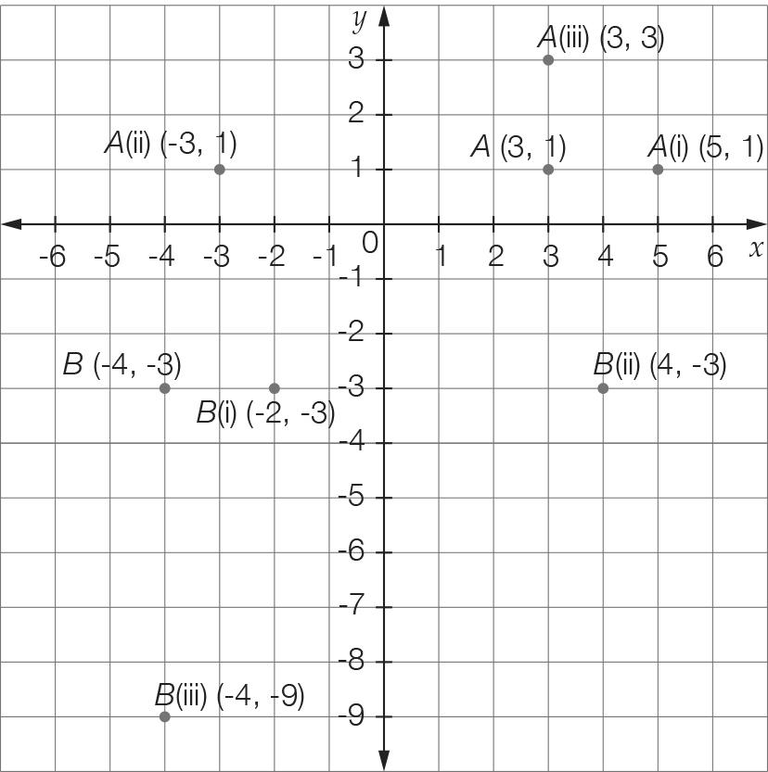

(b) A (i) (5, 1) (ii) (-3, 1) (iii) (3, 3)

B (i) (-2, -3) (ii) (4, -3) (iii) (-4, -9)

Question 10 4 marks [8.2, 8.5]

(a) (i) (0, -9) (ii) (-3, 0) and (3, 0)

(b), (c)  
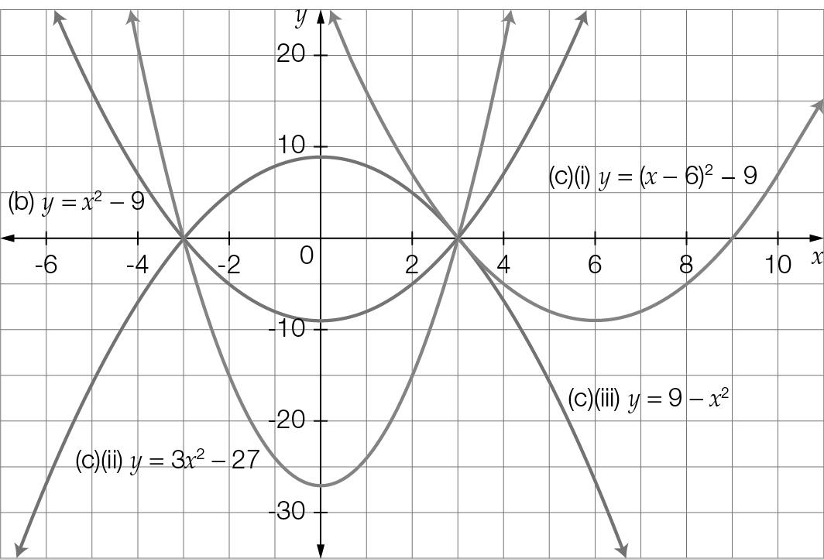

(c) (i) y = (x – 6)2 – 9 (ii) y = 3x2 – 27 (iii) y = 9 – x2

Question 11 4 marks [8.1]

(a)

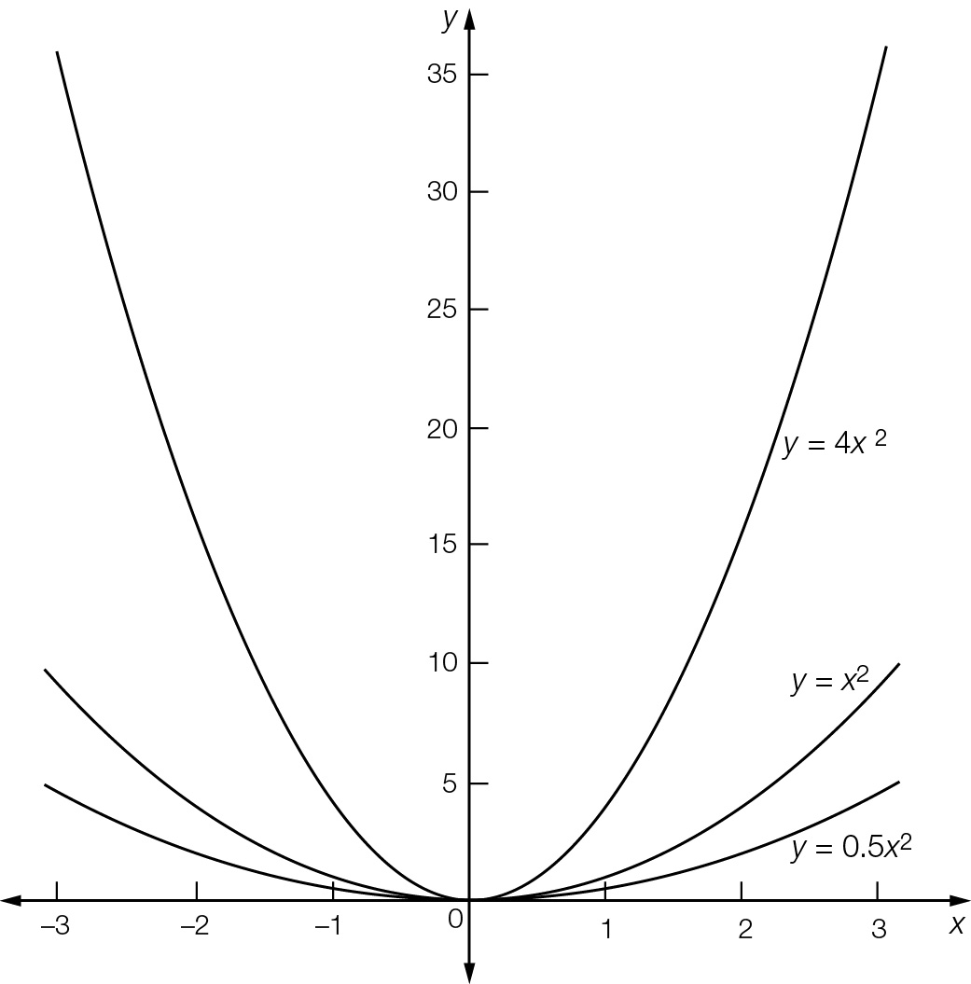

(b) The shape becomes narrower as the coefficient increases.

Question 12 3 marks [8.2]

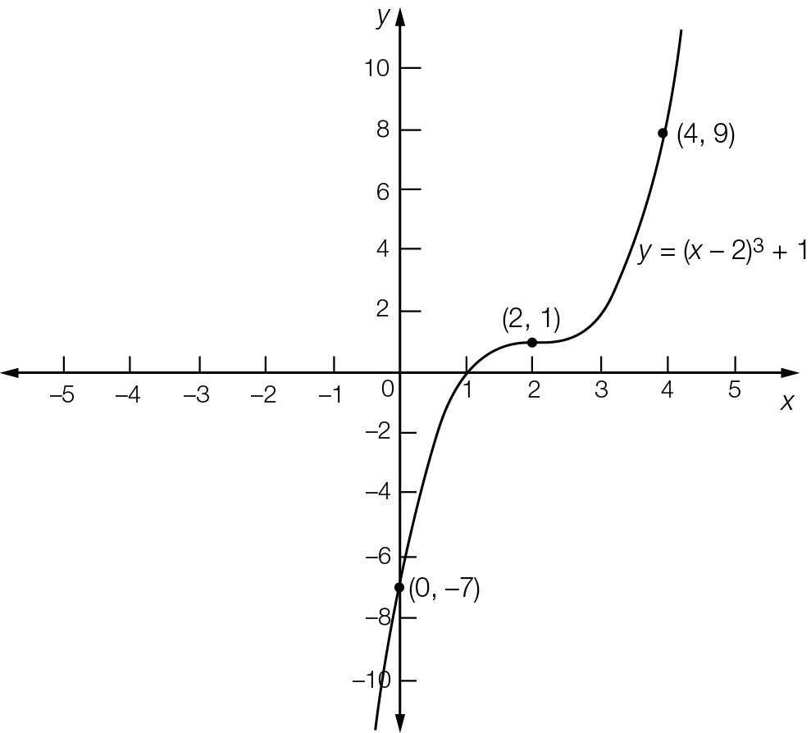

Point of inflection = (2, 1)  
y-intercept = (0, -7)  
Required point = (4, 9)

Question 13 4 marks [8.2]

(a) y = x2  
Translate 2 to the left: y = (x + 2)2   
Translate 2 to the left and 1 down: y = (x + 2)2 – 1

(b) y = x2  
Reflect in the x-axis: y = -x2  
Reflect in the x-axis, dilate by 2 in the x-direction: y = -2x2  
Reflect in the x-axis, dilate by 2 in the y-direction, translate 3 to the left: y = -2(x + 3)2

Question 14 5 marks [8.5]

x = 0, c = -16

x = -2, 4a – 2b – 16 = 0

x = 4, 16a + 4b – 16 = 0

24a = 48 a = 2

8 − 2b − 16 = 0

b = -4

a = 2, b = -4, c = 16

Question 15 2 marks [8.3]

Answers will vary, but the polynomial must have four terms, the highest power of x must be 5 and has a constant term. e.g. 2x5 + 3x2 + 5x – 2

Question 16 4 marks [8.3]

a(x) = 2x – 3, b(x) = 3 – 2x2 and c(x) = 3x2 + 5x – 4

2a(x) × b(x) + c(x)

= 2(2x – 3)(3 – 2x2) + (3x2 + 5x − 4)

= 2(6x − 4x3 − 9 + 6x2) + (3x2 + 5x − 4)

= +12x −8x3 – 18 + 12x2 + 3x2 + 5x − 4

= -8x3 +15x2 + 17x – 22

Question 17 4 marks [8.2]

(a) Reflected in the x-axis: y = -x – 4  
Now reflected in the y-axis: y = x – 4

(b) Reflected in the y-axis: y = -x + 4  
Now reflected in the x-axis: y = x – 4

This is the same answer as in part (a).

Question 18 2 marks [8.3]

Answers will vary. P(2) = 0. For example: P(x) = x3 + 3x2 – 4x – 12

Question 19 2 marks [8.3]

2x2 – kx + 16

Substitute x = 4:

32 – 4k + 16 = 0

4k = 48  
k = 12

Question 20 5 marks [8.3, 8.4]

(a) x2−0x**–** 4

x – 1 ) x3 – x2 − 4x + 4

-(x3 – x2)

-4x +4

-(-4x + 4)

0

So (x – 1) is a factor.

(b) P(x) = (x – 1)(x2 – 4)

= (x – 1)(x + 2)(x – 2)

Short answer total marks: 51

Extended answer section

Question 21 5 marks [8.2]

(a) y = 23 – (x – 5)2 + 2

= 25 – (x – 5)2

(b) Let y = 0

25 – (x – 5)2 = 0

(x – 5)2 = 25

x – 5 = ± 5

x = 0, 10

x = 0 and x = 10 m

(c) Maximum height at vertex (5, 25) is 25 m.

Question 22 6 marks [8.5]

(a) y = 0.01(x3 – 23x2 + 120x)

= 0.01x(x2 – 23x + 120)

= 0.01x(x – 8)(x – 15)

The coordinates of the x-intercepts are (0, 0), (8, 0) and (15, 0).

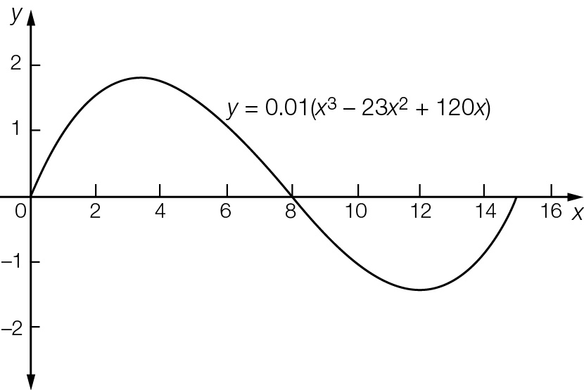

(b)x = 0, 8, 15 (where y = 0)

(c) Distance from one side to the other  
= 15 – 0 = 15 m

Extended answer total marks: 11

TOTAL test marks: 68